Troubleshooting Tools
TASK
1.
Open the command prompt and use the ipconfig tool to find your computer's IPv4 address and default gateway, then take a screenshot of the output.
ANS :
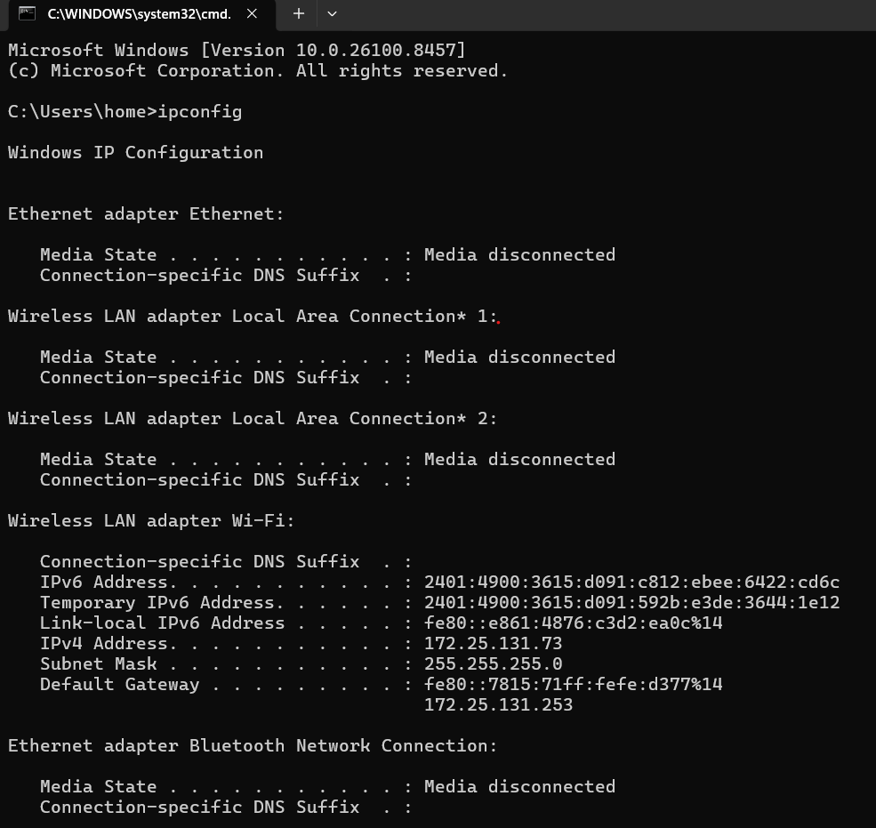

2.
Use the ping command to check the connectivity between your computer and www.google.com, then note down the average response time shown.
ANS :

C:\Users\home>ping www.google.com

Pinging www.google.com [2001:4860:482b:7700::] with 32 bytes of data:
Reply from 2001:4860:482b:7700::: time=67ms
Reply from 2001:4860:482b:7700::: time=70ms
Reply from 2001:4860:482b:7700::: time=140ms
Reply from 2001:4860:482b:7700::: time=193ms

Ping statistics for 2001:4860:482b:7700:::
Packets: Sent = 4, Received = 4, Lost = 0 (0% loss),
Approximate round trip times in milli-seconds:
Minimum = 67ms, Maximum = 193ms, Average = 117ms
3.
Run the tracert (or traceroute on Linux/Mac) command to www.flipkart.com and list the number of hops it takes to reach the destination.
ANS :
C:\Users\home>tracert www.flipkart.com
OUTPUT:
Tracing route to e348826.dscb.akamaiedge.net [2600:140f:8a00::17c1:a560]
over a maximum of 30 hops:

1 3 ms 4 ms 3 ms 2401:4900:3615:d091::6b
2 * * * Request timed out.
3 89 ms 44 ms 45 ms 2401:4900:8c:2408::f1
4 44 ms 39 ms 68 ms 2404:a800:2a00:105::5
5 70 ms 107 ms 98 ms 2404:a800:88::114
6 96 ms 96 ms 82 ms g2600-140f-8a00-0000-0000-0000-17c1-a560.deploy.static.akamaitechnologies.com [2600:140f:8a00::17c1:a560]

Trace complete.
4.
Use the nslookup tool to find the IP address of www.spotify.com and explain in one line what this tool helps you verify.
ANS :
C:\Users\home>nslookup www.spotify.com
OUTPUT :
Server: UnKnown
Address: 172.25.131.253
5.
A friend says they cannot access Zomato’s website from their laptop. Suggest a sequence of three troubleshooting commands (choose from: ping, ipconfig, tracert, nslookup) you would run to diagnose the issue, and briefly state what each command would help you check.<br><br><em><strong>Hint:</strong> Think about checking both network connectivity and DNS resolution.</em>
ANS :
Step 1: Check Network Configuration
Ipconfig
Verifies that the laptop has a valid IP address and default gateway.
Step 2: Check DNS Resolution
nslookup www.zomato.com
- Verifies whether the domain name can be resolved to an IP address.
Step 3: Test Connectivity and Route
ping www.zomato.com
- Checks whether the website's server is reachable and measures response time.
If ping fails but DNS works, run:
tracert www.zomato.com
- Identifies where along the network path the connection is failing.

